**ADITYA COLLEGE OF ENGINEERING, MADANAPALLE**

National Level Techno - Cultural Fest

**ACE Techzion 2020**

13 & 14March 2020

**REGISTRATION FORM**

1. Name of the student(s) :________________________________________________________________

________________________________________________________________

2. Year & Branch : _______________________________________________________________

3. Institute /Organization :________________________________________________________________

________________________________________________________________

4. Mobile Number :________________________________________________________________

5. E-mail ID :________________________________________________________________

6. **Type of Event (give tick mark):**

|  |  |  |  |
| --- | --- | --- | --- |
| **Technical Events** | | **Cultural Events** | |
| **Paper presentation** |  | **Foot loose** … Solo Dance |  |
| **Poster Presentation** |  | **Beats N Steps** … Group Dance |  |
| **Project Expo** |  | **Mic Magnet** … Solo Singing |  |
| **Technical/General Quiz** |  | **Sing N Thrill** … Group Singing |  |
| **Workshop** |  | **Fashionista…** Contemporary Ramp Walk |  |

*\* In the case of paper presentation, send the title of the paper and abstract (soft copy)*

*along with the scanned copy of registration form*

7. Registrartion Fee : _________________________________________________________________________

(Registration fee is Rs.100/- per participant per event)

8. Accommodation needed : (YES/NO)______________________________________________________________

(Rs.150/- per participant per day,which)

**Signature of the student Signature & Seal of HOD/PRINCIPAL**

***Send your registration form to***

CE [acetechzion20.ce@acem.ac.in](mailto:acetechzion20.ce@acem.ac.in) EEE [acetechzion20.eee@acem.ac.in](mailto:acetechzion20.eee@acem.ac.in)

ECE [acetechzion20.ece@acem.ac.in](mailto:acetechzion20.ece@acem.ac.in) ME [acetechzion20.me@acem.ac.in](mailto:acetechzion20.me@acem.ac.in)

CSE [acetechzion20.cse@acem.ac.in](mailto:acetechzion20.cse@acem.ac.in) Cultural [acetechzion20@acem.ac.in](mailto:acetechzion20@acem.ac.in)

**]**

**For further details log on to :** [**www.acem.ac.in**](http://www.acem.ac.in)

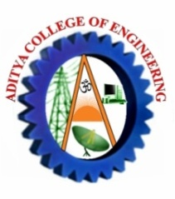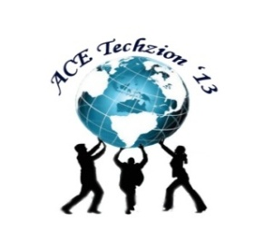**ADITYA COLLEGE OF ENGINEERING**

**MADANAPALLE**

(Approved by AICET,New Delhi & Affiliated to JNTUA, Anantapuramu)

National Level Techno - Cultural Fest

**ACE Techzion 2020**

13 & 14March 2020

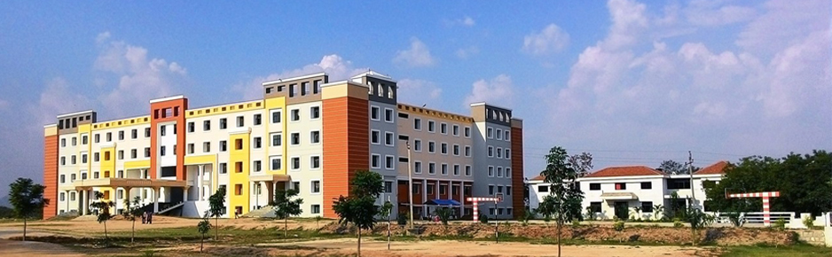

**About ACEM**

Aditya College of Engineering, Madanapalle under the umbrella of Veda Educational Society was Established in the year 2009 to impart excellent technical and value based Education under the able and dynamic leadership of  **Sri R.Ramamohan Reddy,** Secretary & Correspondent and **Sri .M. Nagamalla Reddy**, President. This High Performing and Fast growing College is led by the Principal **Dr. S. Ramalinga Reddy** who is a visionary and is responsible for establishing the culture in the college, setting the academic tone and creating an atmosphere that nurtures excellent teachers as well as students, with the support of the management. This institution has been relentlessly working on grooming young minds and preparing them for delivering value to the society at large with the motto **“Explore, Experience, Excel”.** The Institution offers the courses of ECE, CSE with an intake of 120 students and EEE, ME,CE with an intake of 60 students.

**Theme of Techno-Cultural Fest**

It serves as an excellent platform to bring out innovations & investigations in the areas of latest trends in engineering and technology. Apart from these it provides a well deserving opportunity to explore and Showcase one’s innate creative and aesthetic talents hereby enhancing one’s confidence to face mightier challenges of life.

**Objectives of Symposium**

* Exploring the inherent talents and capabilities of budding engineers
* Awareness towards recent trends
* Add wings to creativity
* Developing communication skills
* Expose to latest developments through interactions

**Important Dates**

* *Submission of the scanned copy of Registration Form to e-mail* ***:*** *on or before* ***04.03.20***
* *Notification of acceptance by e-mail:* ***06.03.20***